

Design Document - CDR-IOS
Version 0.1
Prepared by
Group - 08
Capgemini private Ltd.
02.06.2022

Document Control :

Project Revision History
Date | Version | Author | Brief Description of Changes |  |  |  | Approver Signature
08/08/2022 | 0.1 |  | Basic design and documentation

Team Members

Employee ID | Name
46240972 | Rajanala Durgadevi
46240998 | Hirijashree Rajendran
46238891 | K Rahul Sai
46240802 | Ibbani P

Table of Contents

- High Level Design

1.Introduction |  |  | 4
1.1 | Purpose |  | 4
1.2 | Scope |  | 4
1.3 | Definitions |  | 4
1.4 | Overview |  | 4
2.General Description |  |  | 4
2.1 | Product Perspective |  | 4
2.2 | Tools used |  | 5
2.3 | General Constraints |  | 5
2.4 | Assumptions |  | 5
2.5 | Special Design aspects |  | 5
3.Design Details |  |  | 5
3.1 | Main Design Features |  | 5
3.2 | Application Architecture |  | 5
3.3 | Standards |  | 6
3.4 | Data Flow Diagram |  | 6
3.5 | Files |  | 6
3.6 | Error Handling |  | 6
3.7 |  | Interfaces | 6
3.8 |  | Help | 6
3.9 |  | Performance | 7
3.10 |  | Security | 7
3.11 |  | Reliability | 7
3.12 |  | Maintainability | 7
3.13 |  | Portability | 7
3.14 |  | Reusability | 7
3.15 |  | Application compatibility | 7
3.16 |  | Resource utilization | 7
3.17 |  | Major Classes | 8

- Low Level Design

4. Introduction 9
4.1 Purpose 9 | Purpose
4.2 Document Conventions 9 | Scope
4.3 Intended Audience and Reading Suggestions 9 | Definitions
4.4 References 9 | Overview

5.Detailed System Design 9

5.1 Design Descriptions 9
5.2 CDR Flow Diagram 10

5.3 Class Diagram 10
5.4 Use Case Diagram 11
5.5 Design and Implementation Constraints 12

5.6 User Interfaces 12
5.7 Security 12
- Appendix A: Glossary 13

High Level Design

- Introduction

1.1 Purpose

The purpose of this High Level Design (HLD) Document is to add the necessary detail to the current project description to represent a suitable model for coding. This document is also intended to help detect contradictions prior to coding, and can be used as a reference manual for how the modules interact at a high level.

1.2 Scope

This document provides a comprehensive high level design overview of the Call Data Record. It highlights the high level flow / use cases in inter operator settlement and serves as an input to the low level design documents that would further elaborate on the proposed system design

1.3 Definitions

1.4 Overview

This HLD Document is arranged in the following format :
-Section1 : Introduction

A brief explanation about the purpose, aim, scope and design format of the proposed system.

- Section 2 : General Description

This section is all about the general constraints, assumptions and design aspect associated with the proposed system .The product perspective will gives an overall description of the system.

- Section 3 : Design Details

This section documents the detailed design of all modules associated with the development of the proposed system.

- General Description

2.1 Product Perspective

The Call Data Record aim is to display the aggregate information of operators separately. The concepts used in this system are directory to collect the CDR files, directory to store the CDR files which is range of 1-5 MB, file reader to read the file from directory, parser to parse the CDR file information, multi threading to display the data of operators. The system is basically constructed using C++ language .

2.2 Tools used

- Ubuntu Terminal.
- C++ language is used.
- Draw io is used for pictorial representations.

2.3 General Constraints

The Call Data Record is fixed. We cannot enhance further. Data and user privacy should be the utmost priority.

2.4 Assumptions

To be discussed.

2.5 Special Design aspects

One of the design aspects is that we can display the call data information for both customer billing and inter operator settlement.

3 Design Details

3.1 Main Design Features

The main design features include four major parts: the architecture, the user interface design, the files, process relation, and automation. In order to make these designs easier to understand, the design has been illustrated in attached diagrams ( Use Case, Data flow diagrams).

3.2 Application Architecture

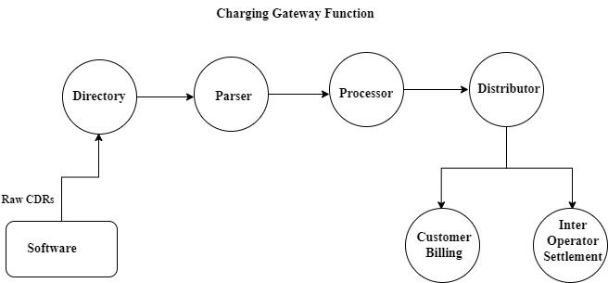

3.3 Standards

Security – The system shall be capable of receiving charging information in the form of CDR data and bulk meter data recorded in the switch and transferred on-line through the data network. In case of on-line transfer, the system shall support a high security for accessing data by providing two paths, an active path and a standby path.

3.4 Data Flow Diagram

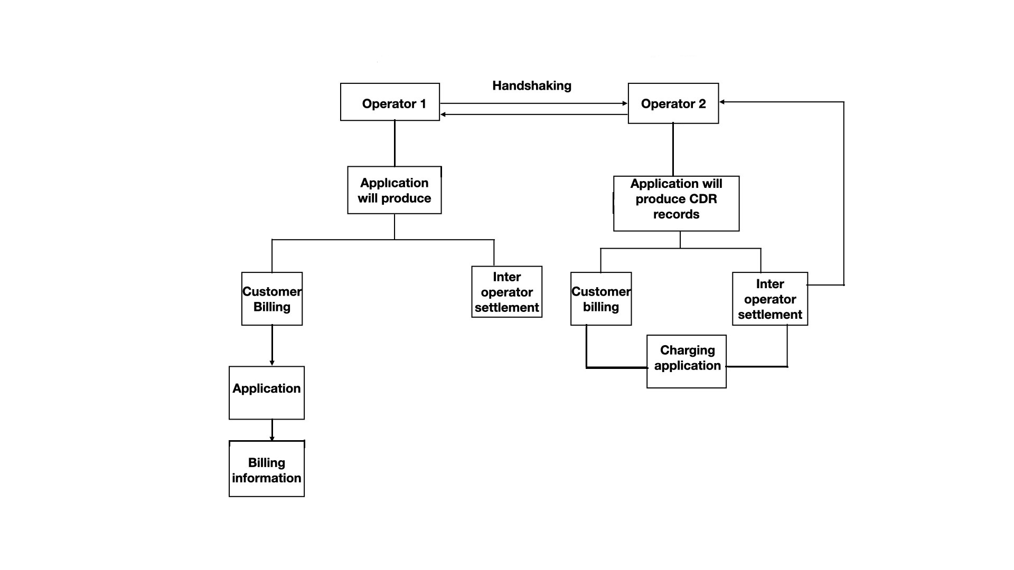

3.5 Files

The Call Data Record is files are the logs which contains information of incoming/ outgoing voice calls/SMS, data downloaded/uploaded. CDR files contains information of several users.

3.6 Error Handling

Should errors be encountered, an explanation will be displayed as to what went wrong.
An error will be defined as anything that falls outside the normal and intended usage.

If there is no file to open, then it will throw an exception that unable to open file.

3.7 Interfaces
Not Applicable

3.8 Help

Help will come in the form of all the documentation created prior to coding, which explain the intended uses.

3.9 Performance

Performance is going to be very important for this project. For everything to run smoothly for this project, The system will work on the CDR file and the performance depends upon the software implementation of inter operator settlement.

3.10 Security

The system shall be capable of receiving charging information in the form of CDR data and bulk meter data recorded in the switch and transferred on-line through the data network. In case of on-line transfer, the system shall support a high security for accessing data by providing two paths, an active path and a standby path.

3.11 Reliability

The system is available when the authenticated person get requested to produce inter-operator settlement information.

3.12 Maintainability

We have to maintain internet data records of subscribers for services provided such as internet access, e-mail, internet telephony services like calls made from mobile application or wifi for at least 2 years.
3.13 Portability

Code and program portability should be possible between kernel-recompiled Linux distributions. For everything to work properly, all components should be compiled from source.

3.14 Reusability

The code written should have the ability to be reused with no problems. Should time allow, and detailed instructions are written on how to create this project, everything will be completely reusable to anyone.

3.15 Application compatibility

The CDR file is compatible to produce the subscriber call information for any operator.

3.16 Resource utilization

The record is maintained by the concerned telephone exchange and contains call details such as time of the call, duration of the call, source and destination number, completion status of the call, etc. Call detail records serve a valuable purpose of revenue generation for telephone service providers and are critical for law enforcement, whenever required.

3.17 Major Classes

There are a total of two classes: Customer, Operator.

Low Level Design

- Introduction

The aim of this document is to gather, analyze and give an in-depth insight into the complete Call data Record Inter Operator Settlement by defining the problem statement in detail. The intended audience includes all stakeholders in the potential system. This include subscribers of each operator. The detailed low level design of the Call data Record Inter Operator Settlement are provided in this document.

  - Purpose

Purpose of this project is to provide A call detail record (CDR) is a data record produced by a telephone exchange or other telecommunications equipment that documents the details of a telephone call or other telecommunications transactions (e.g., text message) that passes through that facility or device. The record contains various attributes of the call, such as time, duration, completion status, source number, and destination number.

Document Conventions

TBD(To Be Discussed)

Intended Audience and Reading Suggestions

Document is primarily intended for members of Call Data Record Inter Operator Settlement team and Mentors which consists of trainees under Capgemini Training Program.

References

https://docstore.mik.ua/univercd/cc/td/doc/product/wanbu/das/das_1_4/das14/das14apd.htm
https://www.gl.com/Presentations/Call-Data-Records-Presentation.pdf
https://en.wikipedia.org/wiki/Call_detail_record

Detailed System Design

The system design is as follows –

5.1 Design Descriptions
Every time a call is placed on a telecommunication network, descriptive information about the call is saved as a Call Data Record (CDR). Millions of CDRs are generated and stored every day. In addition, at minimum, each Call Data Record has to include the originating and terminating phone numbers, the date and time of the call, and the duration of the call. The CDRs might also include other kinds of data that are not necessary but are useful for Inter operator settlement, for instance, the identifier of the telephone exchange writing the record, a sequence number identifying the record, the result of the call (whether it was answered, busy, etc.), the route by which the call entered the exchange, any fault condition encountered, and any features used during the call, such as call waiting.

Call Data Record file have to collect from any software. We have to store those CDR files in directory. To access those file we have to provide authentication for securing those files. Authorized users have to parse the data of MSISDN, MNC/MMC, call type means incoming call/outgoing calls of same/different operator, incoming messages/outgoing messages of same/different operator, data downloaded/uploaded in MB and call duration of same /different operators.

5.2 CDR Activity Diagram

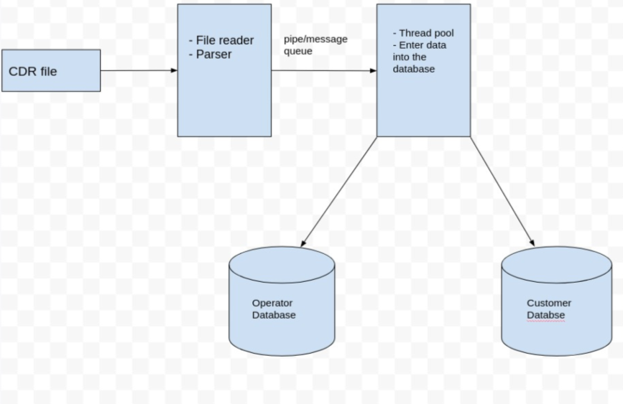

5.3 Class Diagram

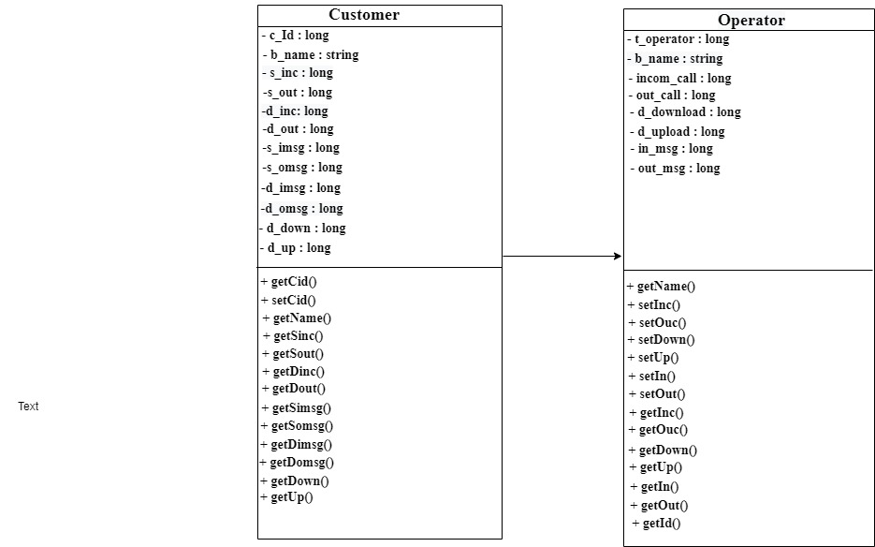

5.4 Use Case Diagram
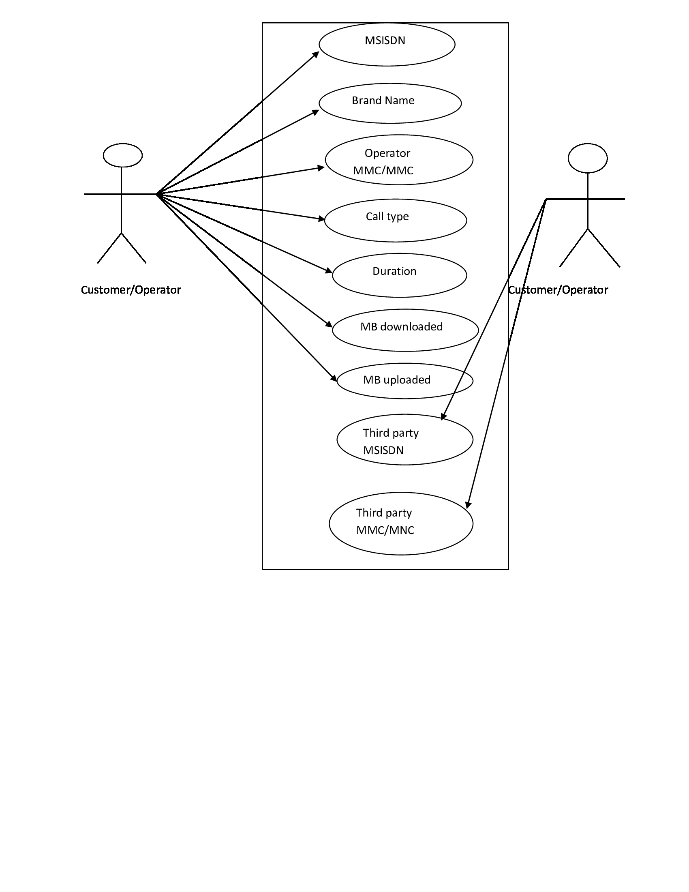
5.5 Design and Implementation Constraints

The system is built using C++ language.

5.6 User Interfaces

We have used the file processing to read CDR file, parsing the data using tokenization, multi threading to do process of inter-operator settlement and hashtable to store the CDR file data as database.

5.7 Security

The Call Data Record itself does not provide authentication and security. We have to store the data in hash table.

- Appendix A: Glossary
CDR | Call Data Record
ISDN | Integrated Services Digital Network
MSISDN | Mobile Subscriber – ISDN Number
MOC | Mobile Originated Call
MTC | Mobile Terminated Call
SMS-MO | Short Message Service- Mobile Originated
SMS-MT | Short Message Service- Mobile Terminated
GPRS | General Packet Radio Services
MCC | Mobile Country Code
MNC | Mobile Network code)
SDR | Subscriber Detail Record
SIM | Subscriber Identity Module
BTS | Base Transceiver Station
IMEI | (International Mobil Equipment Identity
TAC | Type Allocation Code
IMSI | International Mobile Subscriber Identity
CDMA | Code Division Multiple Access
GSM | Global Positioning System
LTE | Long Term Evolution
UMTS | Universal Mobile Telecommunications Service

